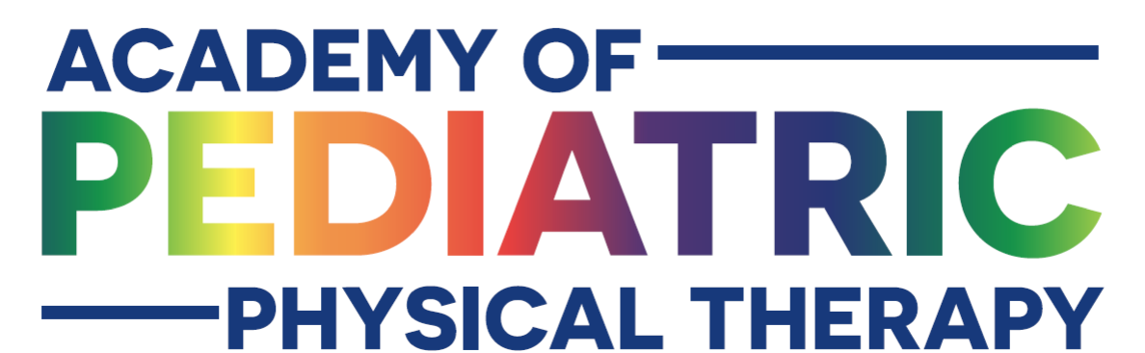
Duathlon at Disneyland Hotel

What: Academy of Pediatric Physical Therapy Annual Conference: Duathlon at Disneyland Hotel
When: Saturday, November 16th, 2019
Where: Disneyland, CA
Who: Children and young adults with physical and developmental disabilities
How many: 50 Participants, 130+ Volunteers, 300+ attendances total with families
Why: To encourage physical fitness and participation for all ability levels. To provide an event for young people of all abilities that promotes physical fitness and encourages activity offering an equal opportunity to those with disabilities.
How to help: We are seeking monetary donations to help with costs of T-shirts, medals, stopwatches, and other event supplies
Donations of items: We are also seeking donations for the day of event. We offer everyone light refreshments in the exhibit hall after the event and we create goodie bags for each athlete.
Goodie bag items: athletic wrist bands, athletic gear, water bottles, swim equipment, bike accessories, “tattoos”, bracelets, keychains, bandanas, coupons, discounts, offers, snacks, toys
Contact: Stephanie Horwitz for more information, donations, and questions
shorwitz31@gmail.com P: 224-234-4662

Commitment Pledge

________________________________ agrees to help sponsor the Disneyland Duathlon for the
(Person, Company, Firm) following amount:

______$500-Gold Medal Sponsor: please send your company's logo to be on the Duathlon t-shirts to be worn by participants and volunteers.

______$250-Silver Medal Sponsor: please send your company's logo to be on the Duathlon t-shirts to be worn by participants and volunteers. These will be smaller than the gold medal sponsor logos.

______$100-Bronze Medal Sponsor: please send your company's logo to join the list on the posters/ handouts displayed the day of the duathlon.

______ Other amount

Items: ______________________________ Respond in an email please with list of items you will donate.

Please return this commitment pledge with your check payable to Academy of Pediatric Physical Therapy memo: Disneyland Duathlon.

If you are a Gold or Silver Medal Sponsor, include a copy of your logo as you would like it to appear on our t-shirt.

If you would rather donate your time, we would love to have you as a volunteer. Please contact us by emailing Stephanie Horwitz - shorwitz31@gmail.com, P: 224-234-4662

Thank you so much for helping us support this fabulous fun event.

-Academy of Pediatric Physical Therapy

